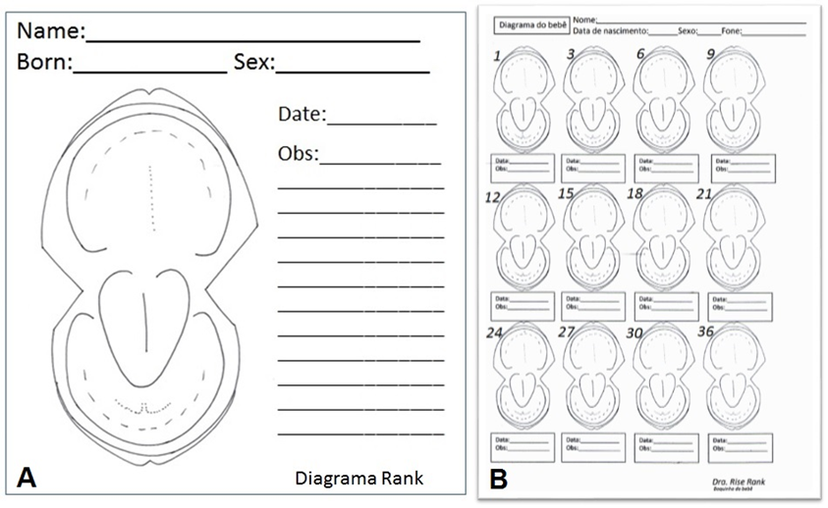
Figure 1: (A) - Schematic drawing of an edentulous child's mouth (individual examination); (B) – Rank Diagram adapted to the children's oral health quarterly follow-up program, from 0 to 36 months of age.

Table 1: Distribution in numbers of the main data obtained in the intraoral clinical exams in relation to hard and soft tissues in the respective age groups in which they were found.

HARD TISSUE | ALTERATION | 0-12  Months |  | 13-24  Months |  | 25-36  Months |  | Total
 |  | F | M | F | M | F | M | n %
Tooth | 1.Carie |  | 01 | 02 |  | 04 | 05 | 12 8.6
 | 2. Dental traumatic injuries | 01 | 01 | 01 | 03 |  | 01 | 07 5.0
 | 3.Agenesis |  |  | 01 | 01 |  | 01 | 03 2.1
 | 4. Enamel hipocalcification |  | 02 | 01 |  |  |  | 03 2.1
 | 5. Enamel hypoplasia |  |  | 01 | 01 |  |  | 02 1.4
 | 6. Geminated' and 'fused' teeth |  | 01 | 02 |  |  |  | 03 2.1
SOFT
TISSUE

Gingival diseases | 7.Gingivitis | 02 | 02 | 01 | 03 |  | 01 | 09 6.5
 | 8.Gingival margin | 02 | 02 |  |  |  |  | 04 2.8
Tongue | 9.Língua Geográfica | 02 | 01 | 02 | 01 |  |  | 06 4.3
 | 10. Ankyloglossia | 05 | 10 |  |  |  |  | 15 10.8
Lip | 11. Congenital lower-lip pits. | 06 | 04 | 01 |  |  |  | 11 7.9
 | 12. Fibrosis of the lips |  |  |  |  | 01 |  | 01 0.7
 | 13.Mucocele | 01 |  |  | 01 | 01 |  | 03 2.1
Cysts | 14. Eruption cysts | 01 | 01 | 01 | 02 |  |  | 05 3.6
 | 15. Inclusion cysts (Epstein's pearls, Bohn's nodules) | 06 | 05 | 01 |  |  |  | 12 8.7
 | 16. Ranula | 01 |  |  |  |  |  | 01 0.7
Total |  | 27 | 30 | 14 | 12 | 06 | 08 | 97

Table 2: The adjusted values residues (Raj) were obtained from standardized residuals values to each cell of Table 1, with reference to the normal distribution reduced to 5% significance level (1.96).
 | 0-12  Meses | 13-24  Meses | 25-36  Meses
 | -3.8* | -0.8 | 6.4*
 | -1.7 | 1.9 | 0
 | -2.1* | 1.6 | 0.9
 | 0.3 | 0.3 | -0.7
 | -1.7 | 2.4* | -0.6
 | -0.9 | 1.6 | -0.7
 | -0.9 | 1.3 | -0.3
 | 1.7 | -1.2 | -0.8
 | -0.5 | 1.3 | -1.0
 | 3.5* | -2.5* | -1.7
 | 2.3* | -1.4 | -1.4
 | -1.2 | -0.6 | 2.4*
 | -0.9 | 0.3 | 0.9
 | -0.9 | 1.7 | -0.9
 | 2.5* | -1.5 | -1.5
 | 0.8 | -0.6 | -0.4
* Residues above +1.96 or below -1.96 indicate significance level of 5%.

Table 3: Distribution in numbers of the perception on the arbitrary scale of the degree of satisfaction, according to the indicators shown in the Rank Diagram.

Series | *Indicators | A | B | C | D | E
GI | Design of edentulous mouth | 22 | 10 | 1
 | Locations for registration of erupted teeth | 17 | 13 | 2 | 1
 | Record of lesions in the gingival tract | 15 | 14 | 2 | 2
 | Record of lesions or tongue changes | 23 | 10
 | Record changes in lips | 18 | 10 | 3 | 2
 | Registration of changes in the frenulum | 24 | 7 | 1 | 1
 | Record of changes in the palate | 23 | 8 | 2
GII | Quarterly follow-up of oral alterations | 27 | 5 | 1
 | Quarterly follow-up of dental eruptions | 21 | 11 | 1
GIII | Instruction manual | 8 | 20 | 4 |  | 1
 | Place to record observations | 7 | 6 | 10 | 6 | 4
 | Practicality for recording oral changes | 22 | 10 |  | 1
 | Sheet printed on A4 paper | 23 | 8 | 2
* A = Very satisfied, B = Satisfied, C = Unsatisfied, D = Unsatisfied and E = Very dissatisfied.

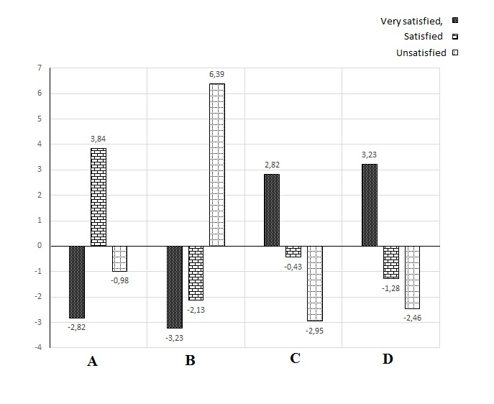
A = Instruction manual; B = Place to record observations; C = Practicality for recording oral changes; D = Sheet printed on A4 paper

Figure 2. Residual analysis: The values of Raj (adjusted residuals) were obtained from standardized residue values for each cell of Table 4, with reference to standard normal distribution at 5% significance (Raj = 1.96).

