Figure and Tables

Figure 1: Images in the poster showing two new postural positions for infants’ oral cleaning.
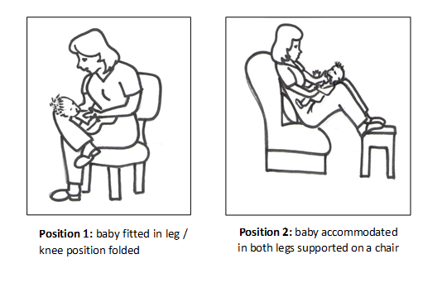

Table 1: Distribution of characteristics of the study sample (mothers and children).
Children  Age in months | 3 ± 1.69
Children’s Gender
Female | 20 (52.6%)
Male | 18 (60.8%)
Mother’s age | 25 ± 7.06
Mother’s education level (yrs)
≤ 8 | 13 (3.,2%)
>8 | 25 (65.7%)
Living with a partner
Yes | 24 (63.1%)
No | 14 (36.8%)
Family income
Less than one minimum wage | 3 (7.9%)
One minimum wage | 21 (55.2%)
Two minimum wage | 12 (31.5%)
Three minimum wage | 2 (5.2%)
Number of children
1 | 11 (28.9%)
2 | 9 (23.6%)
3 | 11 (28.9%)
4 | 7 (18.5%)
Did you plan to breastfeed your child?
Yes | 35 (92.1%)
No | 3 (7.9%)

Table 2: Distribution of questionnaire responses applied to mothers in number and percentage found.

Questions | n | %
How many times a day do you clean the baby’s mouth?
1 | 14 | 36.8
2 | 11 | 28.9
3 | 5 | 13.3
I can not | 8 | 21
Total | 38 | 100
What period(s) of the day do you clean your baby's mouth? (You can check more than one alternative):
Morning | 23 | 60.5
Afternoon | 21 | 55.2
Evening | 13 | 34.2
What do you use to clean the baby’s mouth? (You can check more than one alternative)
Tooth brush | 4 | 10.5
Cloth Diaper | 30 | 79
Gauze | 5 | 13.5
Fingerstall or other | 2 | 5.2
Alguém te ensinou uma postura para limpar a boca do bebê de 0 a 8 meses?
Sim | 1 | 2.6
Não | 33 | 86.8
Não lembro | 5 | 13.2
Total | 38 | 100
How does the baby reach when you clean the mouth?
Calm | 13 | 34.2
Agitated but cooperative | 19 | 50
Agitated but not cooperative | 6 | 15.8
Total | 38 | 100
Does your child have teeth?
Yes | 9 | 23.6
No | 29 | 76.3
Do you, as a mother, find it hard to clean the baby’s mouth?
Yes | 12 | 31.5
No | 26 | 68.5
Total | 38 | 100
If you answered yes, answer why (you can check more than one alternative) – (n-12)
I am afraid I might hurt him | 11 | 91.6
He will not let me do it | 3 | 25
I can not find a proper position | 2 | 16.6
I find it difficult cleaning the baby’s mouth | 5 | 41.6

Table 3: Distribution in numbers of the habitual hygiene position regarding the difficulty found by the mother in the act of cleaning.

difficulty | habitual hygiene position |  | total | p value
 | Lying down | On the lap
Yes | 6 | 6 | 12 | *0.01
No | 3 | 23 | 26
Total | 9 | 29 | 38

Table 4: Distribution in number and percentage of the preference of the new postural positions of oral hygiene chosen by the mothers, with option of more than one alternative.

Reasons for preference | Position 1 |  | Position 2
 | N | % | N | %
Easier to apply | 22 | 75.8 | 1 | 11.1
Faster and the child allows | 2 | 6.8 | 3 | 33.3
More comfortable for the baby | 9 | 31 | 4 | 44.4
More comfortable for the mother | 8 | 27.6 | 5 | 55.5
Can clean the baby's mouth better | 17 | 58.6 | 1 | 11.1
Another reason |  |  | 1 | 11.1
Total | 58 |  | 15
 | p<0,004

